**FLOWCHART**

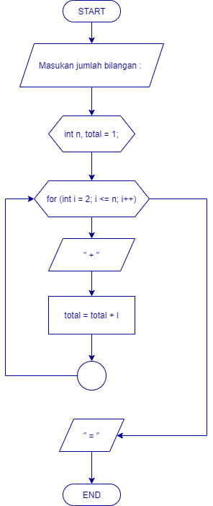

**SOURCE CODE**

**#include <iostream>**

**using namespace std;**

**int main () {**

**int n, total;**

**cout << "----------------------------- " << endl;**

**cout << "| Penjumlahan Deret Bilangan |" << endl;**

**cout << "------------------------------" << endl;**

**cout << endl << endl;**

**cout << "Masukan jumlah bilangan : ";**

**cin >> n;**

**cout << endl;**

**total = 1;**

**cout << 1;**

**for (int i = 2; i <= n; i++) {**

**cout << " + " << i;**

**total = total + i;**

**}**

**cout << " = " << total;**

**cout << endl;**

**return 0;**

**}**

**HASIL PROGRAM**

